Ideation Phase
Define the Problem Statements
Project: Auto Ticket Classification using FLOW DESIGNER
Date | 24 September 2026
Team ID | SWTID-2026-4440
Project Name | Auto Ticket Classification using FLOW DESIGNER
Maximum Marks | 2 Marks
Customer Problem Statement Template:
Create a problem statement to understand your customer's point of view. The Customer Problem Statement template helps you focus on what matters to create experiences people will love.
A well-articulated customer problem statement allows you and your team to find the ideal solution for the challenges your customers face. Throughout the process, you'll also be able to empathize with your customers, which helps you better understand how they perceive your product or service.
For this project the customer is the IT Service Desk agent who works the ServiceNow incident queue, and the product under consideration is an auto ticket classification capability built with Flow Designer.
Reference: https://miro.com/templates/customer-problem-statement/
Example:
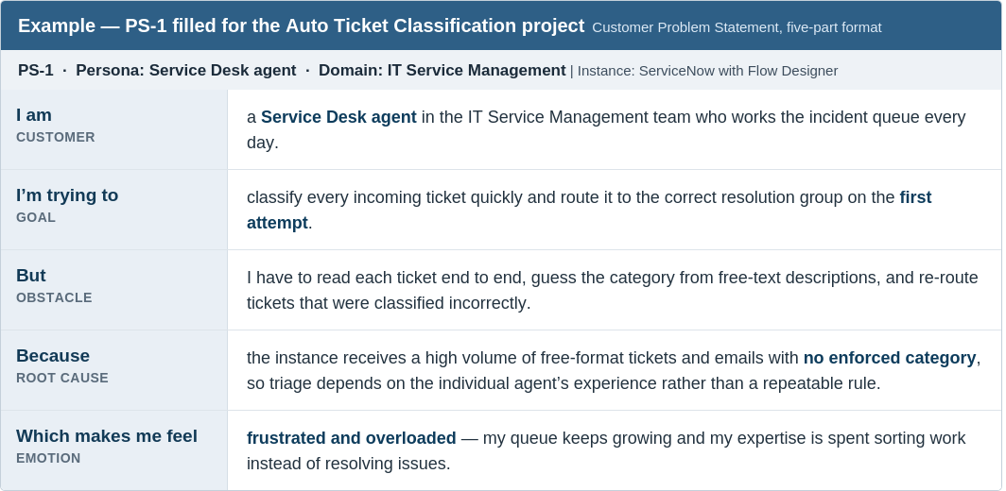
Figure 1 - PS-1 filled in for the Auto Ticket Classification project (five-part problem statement format)

Problem Statement Table
Fill in one row per problem statement. Each row follows the five-part structure: I am (Customer) / I'm trying to / But / Because / Which makes me feel.
Problem Statement (PS) | I am (Customer) | I'm trying to | But | Because | Which makes me feel
PS-1 | a Service Desk agent in the IT Service Management team who works the incident queue every day | classify every incoming ticket quickly and route it to the correct resolution group on the first attempt | I have to read each ticket end to end, guess the category from free-text descriptions, and re-route tickets that were classified incorrectly | the instance receives a high volume of free-format tickets and emails with no enforced category, so triage depends on the individual agent's experience | frustrated and overloaded, because my queue keeps growing and my expertise is spent sorting work instead of resolving issues
PS-2 | an IT Service Management team lead responsible for service level agreements and team workload | keep assignment groups balanced and reduce the number of tickets that breach their resolution target because they were routed to the wrong team | mis-classified tickets bounce between groups and are only corrected after a human notices the delay | classification is a manual decision taken from unstructured text, so there is no consistent rule set that can be measured or improved | concerned about service quality, because the same routing mistakes keep repeating and I cannot prove where they happen
PS-3 | an end user raising an incident through the service portal or by email | receive a fix quickly from the team that actually owns my problem | my ticket waits in the wrong queue before anyone with the right skills sees it | the platform does not read the description of my ticket and predict the right category before a human looks at it | ignored and let down, because a simple issue takes far longer than it should to be resolved

